C# Assignment 3 – Logic gates simulator

Student: July Trendafilov – 4674693

DATE: 02.06.2022

Question 1

1. What is combinatorial logic

Combinatorial logic is a digital logic, implemented in Boolean circuits, where the output is dependent on the values of the inputs in a specific moment.

1. Examples of what can be computed with combinatorial logic
2. Adder

Adder is a combinatorial logic circuit because it is constructed of basic gates and the output is dependent on the input of all pins at a given time, where if an update occurs, the output changes. This way we can compute addition of numbers.

1. Subtractor

Subtractor is a combinatorial logic circuit because it is constructed of basic gates and the output is dependent on the input of all pins at a given time, where if an update occurs, the output changes. This circuit can subtract numbers.

Question 2

* 1. Make a class diagram of the interface, logic components and exceptions

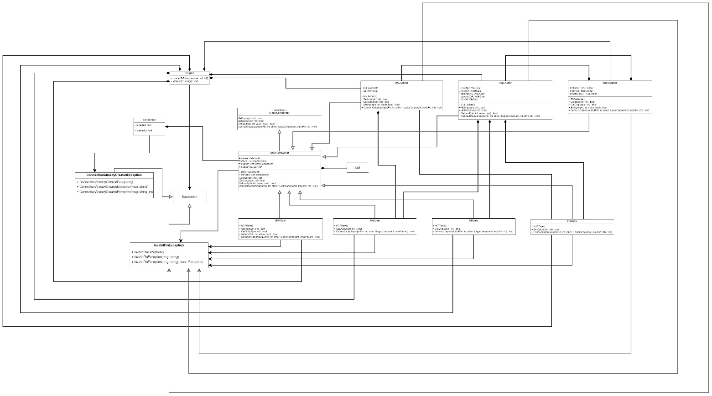

* 1. Make a sequence diagram of producing a truth table of the XOR gate

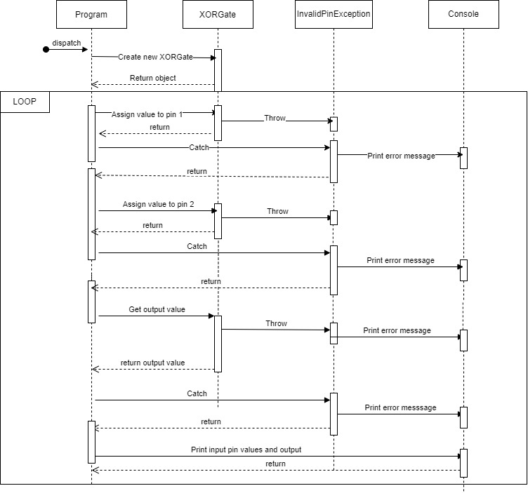

Question 3

1. Give the definition of a half adder

A half adder is an electronic circuit that provides the operation of adding 2 bits and calculating a carry value.

1. Write down with your own words what a half adder is and what are its uses

A half adder is a circuit that provides half of the operation for adding two bits. If we connect two half adders and an OR gate, we get a full adder. A half adder can be used in larger circuits which is better. We can add as many adders as we want but it has a just two inputs.

1. The circuit diagram of a half adder

1. Inputs and outputs

The inputs of this logic gate are two and both represent a bit. The XOR then checks if they are different than each other or not. If not, the output is LOW and else it is HIGH.

1. Truth table

|  |  |  |  |
| --- | --- | --- | --- |
| A | B | SUM | C out |
| 0 | 0 | 0 | 0 |
| 0 | 1 | 1 | 0 |
| 1 | 0 | 1 | 0 |
| 1 | 1 | 0 | 1 |

Question 4

1. Definition of composition

In Object oriented programming composition means to create a part-of relationship between two classes. To do so we create an object of a class inside another class. When the main object is destroyed, the inner objects are deleted too.

1. Pros and Cons of composition
2. Pros

Using composition, the programmer can decide which functionality to expose from the composite class. When in case of class expansion, composition requires less code to improve and is easily readable.

1. Cons

The behavior of the system is harder to understand. Object composition is a run-time feature and to use it properly, one should understand completely the concept.